WORKSHEET 1

**Submitted By: Sadaf Akhtar Ansari**

**Student ID: 24030177**

**SUBMITTED TO:   
SUBMISSION DATE:**

**QUESTION 1.1**

1. Write a program that takes a temperature value from the user. It should then allow the user to choose between Celsius (C) and Fahrenheit (F) for conversion. After the user selection, it should then convert the entered temperature to the chosen scale and display the result.

Use appropriate data types for temperature and handle error like non-numeric input.

Use the following formula for conversion:

F = (C x 9/5) + 32

C = (F - 32) x 5/9

CODE:

#include <iostream>

using namespace std;

int main() {

    double temp;

    char choice;

    cout << "Enter the temperature: ";

    cin >> temp;

    cout << "Convert to Celsius (C) or Fahrenheit (F)? ";

    cin >> choice;

    if (choice == 'C' || choice == 'c') {

        double celsius = (temp - 32) * 5.0 / 9.0;

        cout << "Temperature in Celsius: " << celsius << "�C" << endl;

    }

    else if (choice == 'F' || choice == 'f') {

        double fahrenheit = (temp * 9.0 / 5.0) + 32;

        cout << "Temperature in Fahrenheit: " << fahrenheit << "�F" << endl;

    }

    else {

        cout << "Invalid choice! Please enter 'C' or 'F'." << endl;

    }

    return 0;

}

# Output

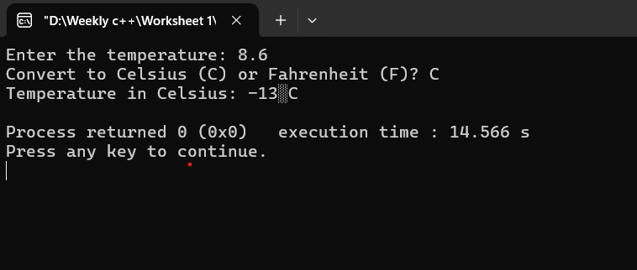

**QUESTION 1.2**

1. Write a C++ program to implement a number guessing game with different difficulty levels.

Easy difficulty ranges from 1-8, medium from 1-30, hard from 1-50.Then,generate a random number to check if the guess is correct based on the user's selection.

**CODE:**

#include <iostream>

#include <ctime> // For generating random numbers

using namespace std;

int main() {

srand(time(0));

int easy = rand() % 8 + 1;

int medium = rand() % 30 + 1;

int hard = rand() % 50 + 1;

int guess;

char difficulty;

cout << " Welcome to the Ultimate Guessing Challenge" << endl;

cout << "Select a difficulty level:" << endl;

cout << " (E) Easy (M) Medium (H) Hard" << endl;

cout << "Enter your choice: ";

cin >> difficulty;

switch (difficulty) {

case 'e': case 'E':

cout << "\nYou chose Easy! Guess a number between 1 and 8: ";

cin >> guess;

if (guess == easy) {

cout << "🎉 Well done! You nailed it!" << endl;

} else {

cout << " The correct number was " << easy << "Better luck next time" << endl;

}

break;

case 'm': case 'M':

cout << "You chose Medium! Guess a number between 1 and 30: ";

cin >> guess;

if (guess == medium) {

cout << " Amazing! You guessed it right!" << endl;

} else {

cout << "Not quite! The number was " << medium << "Try again!" << endl;

}

break;

case 'h': case 'H':

cout << "You chose Hard! Guess a number between 1 and 50: ";

cin >> guess;

if (guess == hard) {

cout << "Incredible! You're a guessing master" << endl;

} else {

cout << "No luck! The correct number was " << hard << ". Don't give up" << endl;

}

break;

default:

cout << "Invalid option! Please restart the game and pick E, M, or H." << endl;

}

return 0;

}

OUTPUT:

**QUESTION 1.3**

1. Write a program that reads an array of integer numbers from the user and sorts the numbers in the ascending order.

**Code:**

#include <iostream>

#include <algorithm> // for sort

using namespace std;

int main() {

int n, arr[100];

cout << "How many numbers? ";

cin >> n;

if (n <= 0 || n > 100) {

cout << "Invalid number!" << endl;

return 1;

}

cout << "Enter the numbers:" << endl;

for (int i = 0; i < n; i++) {

cin >> arr[i];

}

sort(arr, arr + n); //sort() function

cout << "Numbers in order: ";

for (int i = 0; i < n; i++) {

cout << arr[i] << " ";

}

cout << endl;

return 0;

}

Output:

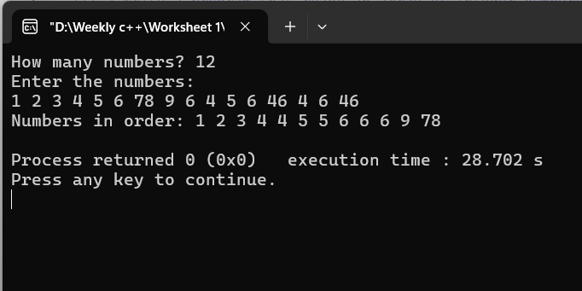

**QUESTION 1.4**

1. Write a program that reads a number from the user and based on the user input, it says what day of the week it is, Sundays being 1 and Saturdays being 7. You system should give appropriate response for invalid input entries.

CODE:

#include <iostream>

using namespace std;

int main() {

int day;

cout << "Enter a number (1-7): ";

cin >> day;

switch (day) {

case 1: cout << "Sunday"; break;

case 2: cout << "Monday"; break;

case 3: cout << "Tuesday"; break;

case 4: cout << "Wednesday"; break;

case 5: cout << "Thursday"; break;

case 6: cout << "Friday"; break;

case 7: cout << "Saturday"; break;

default: cout << "Invalid day";

}

cout << endl;

return 0;

}

OUTPUT:

**QUESTION 2.1**

1. Create a program that takes a positive integer as input and determines whether it's a "bouncy number". A bouncy number is one where the digits neither consistently increase nor consistently decrease when read from left to right. For example:

* 123 is NOT bouncy (digits consistently increase)
* 321 is NOT bouncy (digits consistently decrease)
* 120 is bouncy (neither consistently increasing nor decreasing)

CODE:

#include <iostream>

using namespace std;

bool isBouncy(int n) {

if (n < 100) return false;

bool up = false, down = false;

int last = n % 10;

n /= 10;

while (n > 0) {

int curr = n % 10;

if (curr < last) up = true; //Checking increasing trend

if (curr > last) down = true; //decreasing trend

if (up && down) return true;

last = curr;

n /= 10;

}

return false;

}

int main() {

int n;

cout << "Enter a number: ";

cin >> n;

if (isBouncy(n))

cout << n << " is bouncy." << endl;

else

cout << n << " is not bouncy." << endl;

return 0;

}

OUTPUT:

**QUESTION 3.1**

1. Write a program that manages a cinema ticket booking system. The program should display a 5x5 seating arrangement where:
   1. Available seats are marked with 'O'
   2. Booked seats are marked with 'X'

Program should:

* 1. Display the current seating arrangement
  2. Ask user for row and column number (1-5) for booking
  3. Mark that seat as booked ('X')
  4. Show updated seating after each booking
  5. Display error if user selects already booked seat
  6. Display error if user enters invalid row/column numbers

CODE:

#include <iostream>

using namespace std;

int main() {

char seats[5][5] = { // Create a 5x5 seating chart, 'O' means seat is open

{'O', 'O', 'O', 'O', 'O'},

{'O', 'O', 'O', 'O', 'O'},

{'O', 'O', 'O', 'O', 'O'},

{'O', 'O', 'O', 'O', 'O'},

{'O', 'O', 'O', 'O', 'O'}

};

while (true) { // Keep booking seats until user wants to stop

cout << "Cinema Seats:\n";

for (int i = 0; i < 5; i++) { // Show all seats

for (int j = 0; j < 5; j++) {

cout << seats[i][j] << " ";

}

cout << endl;

}

int row, col;

cout << "Enter row (1-5): ";

cin >> row;

cout << "Enter column (1-5): ";

cin >> col;

if (row == 0 && col == 0) { // 0 0 means exit

cout << "Exiting...\n";

break;

}

if (row < 1 || row > 5 || col < 1 || col > 5) { // Check if input is valid

cout << "Invalid seat! Pick from 1 to 5.\n";

continue;

}

row--; // Change to array index (0-4)

col--;

if (seats[row][col] == 'X') { // If seat already booked

cout << "Seat already booked. Pick another.\n";

continue;

}

seats[row][col] = 'X'; // Book the seat

cout << "Seat booked!\n";

char more;

cout << "Book another seat? (y/n): ";

cin >> more;

if (more == 'n' || more == 'N') {

cout << "Exiting...\n";

break;

}

}

return 0;

}

OUTPUT:

